Student Id: 20032381

Name: Avinash Virupaksh Desai

**Predictive Maintenance in Heavy Machinery: A Machine Learning Approach Using Vibration and Temperature Sensor Data**

**Abstract**

Predictive maintenance (PdM) has become a crucial aspect of industrial maintenance strategies, leveraging data analytics and machine learning (ML) to predict failures before they occur. Unlike traditional reactive and preventive maintenance approaches, PdM aims to optimize equipment performance and reduce unplanned downtime by analyzing real-time sensor data, including vibration and temperature readings. With the advent of Industry 4.0, the integration of artificial intelligence (AI), Internet of Things (IoT), and advanced ML models has revolutionized maintenance practices. This project proposal explores the evolution of PdM, challenges in ML-based approaches, the role of transfer learning (TL), and future research directions.

**Research Questions**

1. Can a machine learning model using sensor data predict failures in advance?
2. How can machine learning improve predictive maintenance in heavy machinery using vibration and temperature sensor data?

**Research Assumptions**

1. The dataset (AI4I 2020) accurately represents real-world machine operations and failure scenarios.
2. Temperature and vibration (modeled through process variables like torque and rotational speed) are sufficient to model and predict failure modes.
3. Failure labels in the dataset correctly reflect true machine states.
4. Machine learning models generalize to similar unseen data without significant degradation.
5. Data preprocessing does not introduce bias.

**Research Philosophy**

This study adopts a positivist research philosophy, assuming that machine behavior can be objectively understood and predicted using quantifiable sensor data. The methodology relies on empirical evidence derived from data to develop models that forecast failure events.

**Literature Review**

Transfer Learning in Predictive Maintenance, Azari et al. (2023) explore the application of transfer learning for predictive maintenance in Industry 4.0 environments. Transfer learning, which involves leveraging pre-trained models to predict faults in new machinery, has shown promise in scenarios where labeled data is scarce. The study highlights how transfer learning can improve fault detection by applying knowledge gained from similar systems to predict failures in different machinery, thus enhancing the model's generalization and accuracy. This approach is particularly relevant for PdM systems in heavy machinery, where acquiring labeled data for every machine type can be resource-intensive.

IoT-Enabled Machine Learning, Madasamy et al. (2023) discuss the role of IoT in enabling machine learning for predictive maintenance in Industry 4.0. IoT devices such as vibration and temperature sensors generate large volumes of real-time data, which can be processed using machine learning algorithms to predict potential equipment failures. The study emphasizes that the integration of these sensors with advanced machine learning techniques, such as deep learning, can lead to more accurate and timely predictions of maintenance needs. IoT-enabled predictive maintenance offers a scalable and efficient solution for monitoring the health of heavy machinery.

Vibration Analysis for Predictive Maintenance, Pavithra and Ramachandran (2021) provide an overview of how vibration analysis has been used for predictive maintenance in industrial machinery. Vibration data is often indicative of mechanical faults, such as imbalances, misalignments, or bearing wear. Machine learning models, particularly those using time-series analysis, can analyze vibration signals to detect anomalies that may signal impending failures. This approach has been widely adopted in heavy machinery industries due to the direct relationship between vibrations and mechanical health.

Uncertainty-Aware Deep Learning, Shao et al. (2023) introduce uncertainty-aware deep learning as a promising tool for fault diagnosis in industrial applications. Their study focuses on the incorporation of uncertainty quantification into deep learning models to enhance the reliability of predictive maintenance systems. Uncertainty-aware models can better handle noisy sensor data, such as that obtained from temperature and vibration sensors, improving the robustness and trustworthiness of fault detection systems. This is crucial in real-world industrial settings where sensor data can be subject to various sources of uncertainty.

Hybrid Deep Learning Models for Fault Diagnosis Zabin et al. (2022) propose a hybrid deep transfer learning architecture that combines Hilbert transform and deep convolutional neural networks (DCNN) with long short-term memory (LSTM) networks for industrial fault diagnosis. This approach leverages both time-domain and frequency-domain features extracted from vibration signals, improving fault classification accuracy. By combining these models with temperature data, which provides complementary insights into thermal anomalies, such hybrid systems can offer a more comprehensive analysis of machine health, thus enabling more accurate predictive maintenance solutions.

**Methods**

**Data Collection**

Link:<https://archive.ics.uci.edu/dataset/601/ai4i+2020+predictive+maintenance+dataset>

This dataset consists of 10,000 data points with 14 features, including sensor measurements like air temperature and process temperature, suitable for predictive maintenance applications.

The dataset consists of 10 000 data points stored as rows with 14 features in columns

UID: unique identifier ranging from 1 to 10000

product ID: consisting of a letter L, M, or H for low (50% of all products), medium (30%) and high (20%) as product quality variants and a variant-specific serial number

air temperature [K]: generated using a random walk process later normalized to a standard deviation of 2 K around 300 K

process temperature [K]: generated using a random walk process normalized to a standard deviation of 1 K, added to the air temperature plus 10 K.

rotational speed [rpm]: calculated from a power of 2860 W, overlaid with a normally distributed noise

torque [Nm]: torque values are normally distributed around 40 Nm with a Ïƒ = 10 Nm and no negative values.

tool wear [min]: The quality variants H/M/L add 5/3/2 minutes of tool wear to the used tool in the process. and a 'machine failure' label that indicates, whether the machine has failed in this particular datapoint for any of the following failure modes are true.

The machine failure consists of five independent failure modes

tool wear failure (TWF): the tool will be replaced of fail at a randomly selected tool wear time between 200 â€“ 240 mins (120 times in our dataset). At this point in time, the tool is replaced 69 times, and fails 51 times (randomly assigned).

heat dissipation failure (HDF): heat dissipation causes a process failure, if the difference between air- and process temperature is below 8.6 K and the toolâ€™s rotational speed is below 1380 rpm. This is the case for 115 data points.

power failure (PWF): the product of torque and rotational speed (in rad/s) equals the power required for the process. If this power is below 3500 W or above 9000 W, the process fails, which is the case 95 times in our dataset.

overstrain failure (OSF): if the product of tool wear and torque exceeds 11,000 minNm for the L product variant (12,000 M, 13,000 H), the process fails due to overstrain. This is true for 98 datapoints.

random failures (RNF): each process has a chance of 0,1 % to fail regardless of its process parameters. This is the case for only 5 datapoints, less than could be expected for 10,000 datapoints in our dataset.

If at least one of the above failure modes is true, the process fails and the 'machine failure' label is set to 1. It is therefore not transparent to the machine learning method, which of the failure modes has caused the process to fail.

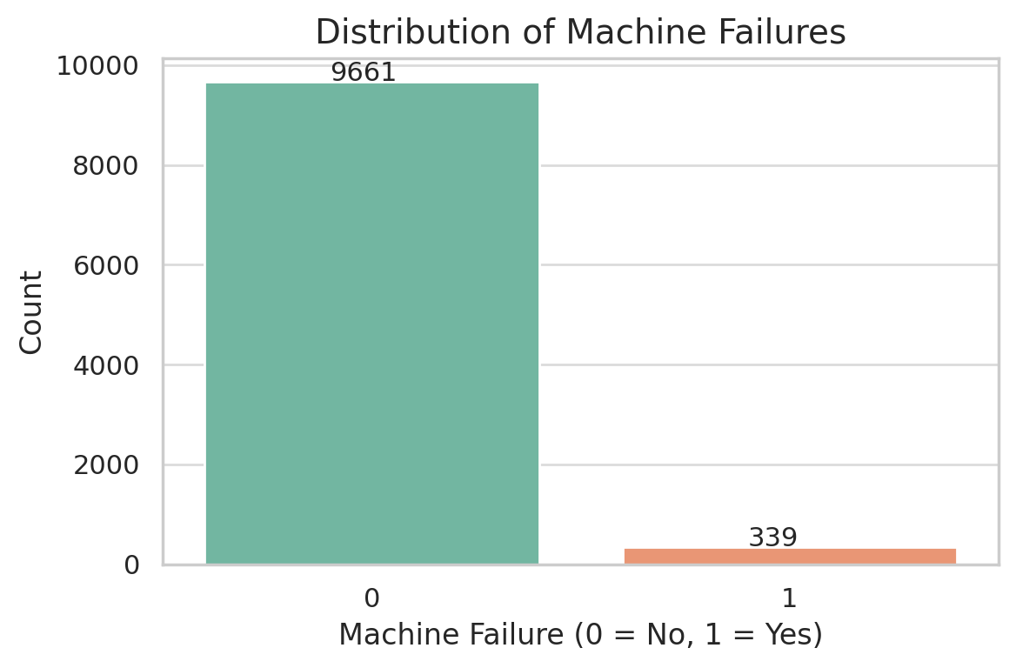

**Model Training**

Before training, the SMOTE model can be applied to balance the dataset. Machine learning techniques have significantly enhanced predictive maintenance by enabling early fault detection, failure classification, and remaining useful life (RUL) prediction. Several ML approaches have been employed in PdM, including supervised learning, unsupervised learning, and deep learning

Supervised learning approach  
Supervised learning methods require labeled data for training predictive models. Common algorithms include:

* Decision Trees & Random Forests: These models are effective in classifying machine states based on sensor inputs.
* Support Vector Machines (SVMs): Applied in anomaly detection and fault classification.
* Artificial Neural Networks (ANNs): Used in pattern recognition for complex sensor data

Unsupervised Learning Approaches  
Unsupervised learning is beneficial when labeled failure data is scarce. Popular techniques include

* K-Means Clustering: Identifies hidden patterns and clusters machine conditions.
* Autoencoders: Learns normal operating conditions and detects anomalies.

Deep Learning for Predictive Maintenance

Deep learning (DL) models have demonstrated superior performance in analyzing time-series sensor data:

* Convolutional Neural Networks (CNNs): Extract features from vibration waveforms for fault detection.
* Long Short-Term Memory (LSTM) Networks: Analyze sequential data for RUL estimation

Despite the success of ML and DL models, challenges such as limited failure data, domain variability, and computational complexity remain significant barriers to adoption

Challenges in Traditional Machine Learning Approaches

Several key challenges hinder the widespread adoption of ML-based PdM:

1. Lack of Failure Data: Since machine failures are rare, labeled failure datasets are limited, affecting model accuracy.
2. Data Distribution Variability: Sensor data differs across machines, making it difficult to generalize models.
3. High Computational Costs: Training deep learning models requires extensive computational resources.
4. Negative Transfer Learning: When knowledge from one machine is transferred to another, performance may degrade due to feature differences

These challenges necessitate the adoption of advanced techniques such as transfer learning (TL) to enhance model adaptability and robustness.

Transfer Learning for Predictive Maintenance  
Transfer learning (TL) has emerged as a powerful technique to address the limitations of traditional ML models. TL enables knowledge transfer from one dataset (source domain) to another (target domain), reducing the need for extensive labeled data and computational resources

Feature-Based Transfer Learning

* Domain Adaptation: Aligns feature distributions between different machines.
* Principal Component Analysis (PCA): Extracts key features for cross-domain generalization.

Parameter-Based Transfer Learning

* Fine-tuning Pre-trained Models: CNN or LSTM models trained on one machine are adapted to another with minimal data.
* Few-Shot Learning (FSL): Enables ML models to learn from limited labeled data.

Studies highlight the effectiveness of TL in overcoming data scarcity and improving PdM model performance across different industrial applications.

#### **Model Evaluation**

After training the machine learning models, it is essential to evaluate their performance to ensure that they can accurately predict machinery health and detect faults. The following evaluation metrics are commonly used:

* Accuracy: The percentage of correct predictions (both true positives and true negatives).
* Precision and Recall: Precision measures the number of true positive predictions divided by the total number of positive predictions, while recall measures the ability of the model to identify all actual faults.
* F1-Score: The harmonic mean of precision and recall, providing a balanced measure of model performance.
* ROC-AUC: The Receiver Operating Characteristic - Area Under the Curve is used to evaluate the performance of classification models, especially in imbalanced datasets where the number of failure instances is much smaller than the number of normal instances.

| **Metric** | **Definition** | **Importance in PdM** |
| --- | --- | --- |
| Accuracy | (TP + TN) / Total | General performance indicator |
| Precision | TP / (TP + FP) | Important when false positives are costly |
| Recall | TP / (TP + FN) | Critical in minimizing missed failures |
| F1 Score | 2 × (Precision × Recall) / (Precision + Recall) | Balance between precision and recall |
| ROC-AUC | Area under ROC curve | Assesses model’s ability to distinguish classes |

**Conclusion**

Machine learning has transformed predictive maintenance by leveraging vibration and temperature sensor data for fault detection in heavy machinery. However, challenges such as data scarcity, domain variability, and high computational costs persist. Transfer learning has emerged as a promising approach to mitigate these issues, enabling knowledge reuse and improving model adaptability. Future research should focus on multi-source TL approaches, digital twin integration, and mitigating negative transfer effects to enhance the efficiency and robustness of PdM models.

**Relevance Tree**

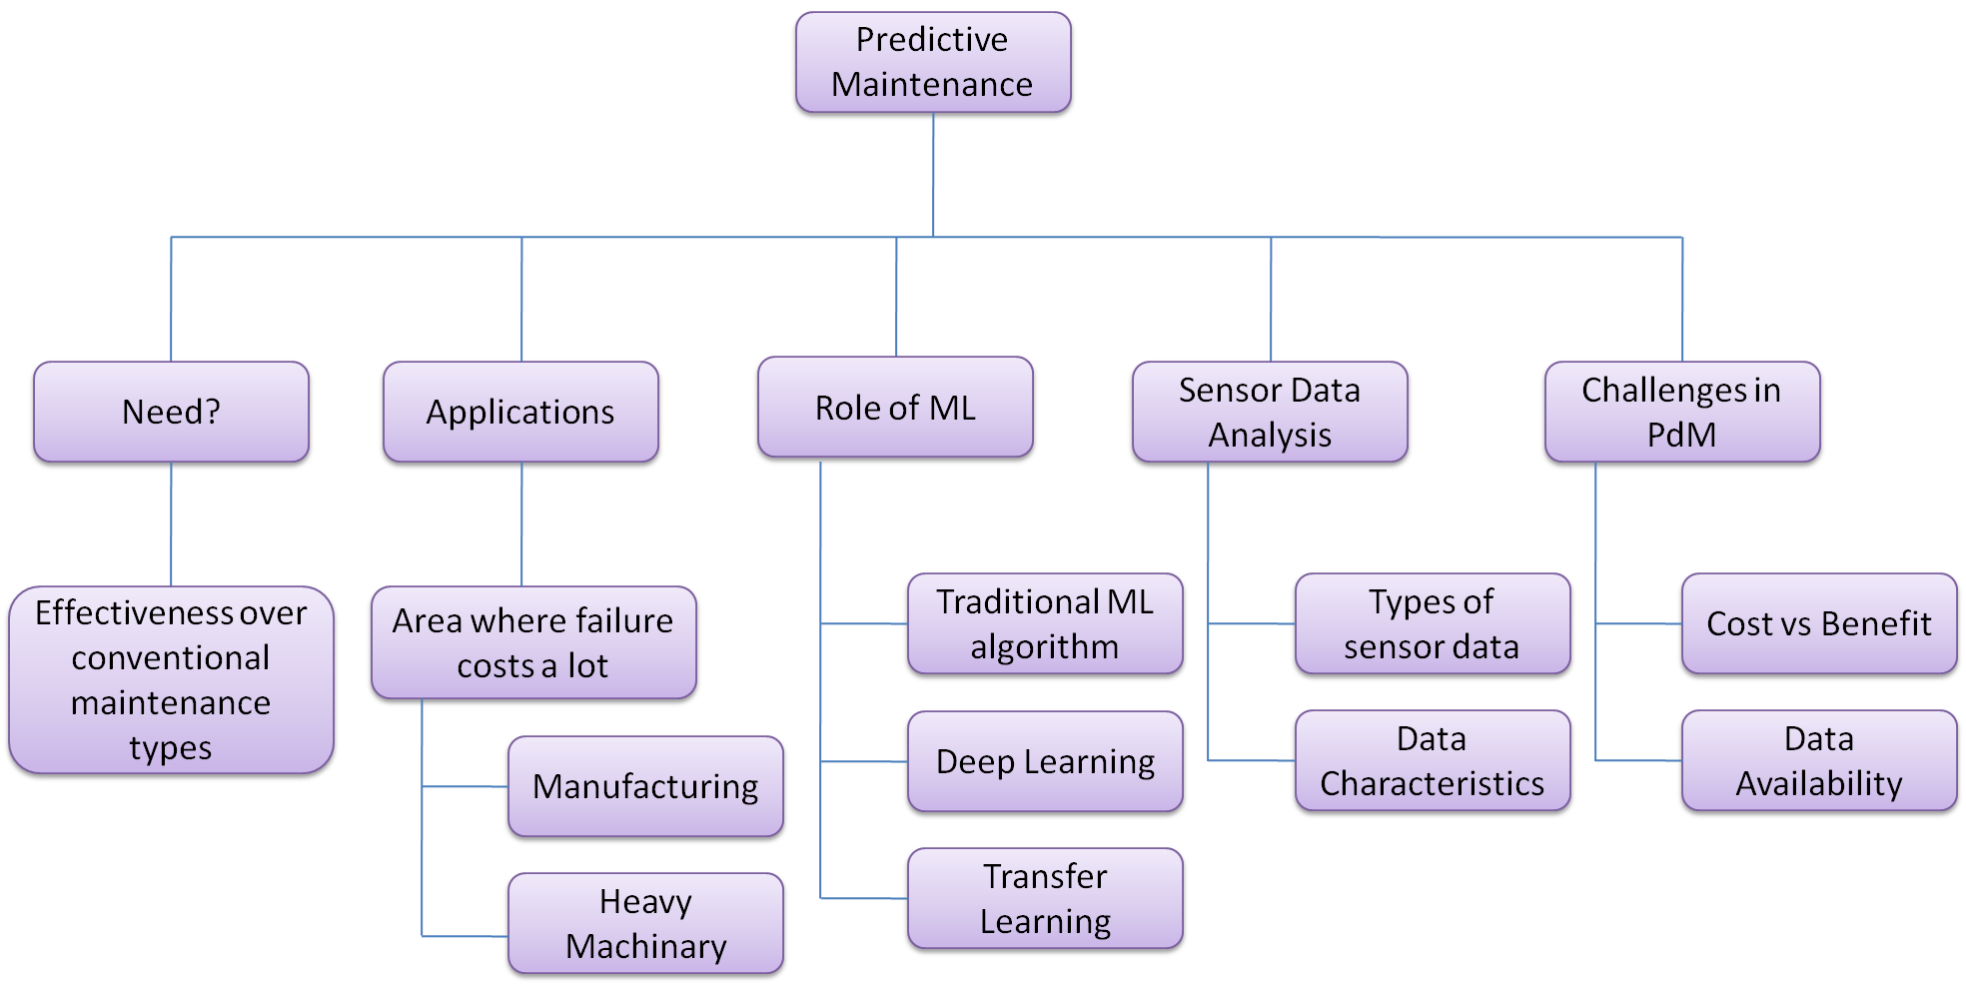

**References**

Azari, M.S., Flammini, F., Santini, S. and Caporuscio, M. (2023) ‘A systematic literature review on transfer learning for predictive maintenance in Industry 4.0’, *IEEE Access*, 11. Available at:<https://doi.org/10.1109/ACCESS.2023.3239784>

Madasamy, S., Shankar, B.P., Yadav, R.K. and Jayalakshmi, K.P. (2023) ‘A machine learning approach in predictive maintenance in the IoT enabled Industry 4.0’, in *Proceedings of the 4th International Conference on Smart Electronics and Communication (ICOSEC 2023)*, pp. 418–423. Available at:<https://doi.org/10.1109/ICOSEC58147.2023.10276226>

Pavithra, R. and Ramachandran, P. (2021) ‘An overview of predictive maintenance for industrial machine using vibration analysis’, in *3rd IEEE International Virtual Conference on Innovations in Power and Advanced Computing Technologies (i-PACT 2021)*. Available at:<https://doi.org/10.1109/i-PACT52855.2021.9696751>

Singgih, M.L., Zakiyyah, F.F. and Andrew (2024) ‘Machine learning for predictive maintenance: A literature review’, in *2024 7th International Conference on Vocational Education and Electrical Engineering (ICVEE 2024): Charting the Course of Artificial Technology in Sustainable Society*, pp. 250–256. Available at:<https://doi.org/10.1109/ICVEE63912.2024.10823713>

Zhang, N., Zhao, J., Ma, L., Kong, H. and Li, H., 2022. *Tool wear monitoring based on transfer learning and improved deep residual network*. IEEE Access. Available at:<https://ieeexplore.ieee.org/document/9941668>

Shao, H., Li, W., Cai, B., Wan, J., Xiao, Y. and Yan, S., 2023. *Uncertainty-aware deep learning: A promising tool for trustworthy fault diagnosis*. IEEE Transactions on Industrial Informatics. Available at: https://www.ieee-jas.net/article/doi/10.1109/JAS.2024.124290

Serradilla, O., Zugasti, E. and Zurutuza, U., 2020. *Deep learning models for predictive maintenance: A survey, comparison, challenges and prospect*. arXiv preprint arXiv:2010.03207. Available at:<https://arxiv.org/abs/2010.03207>

Samatas, G.G., Moumgiakmas, S.S. and Papakostas, G.A., 2021. *Predictive maintenance—Bridging artificial intelligence and IoT*. arXiv preprint arXiv:2103.11148. Available at:<https://arxiv.org/abs/2103.11148>

Zabin, M., Choi, H.J. and Uddin, J., 2022. *Hybrid deep transfer learning architecture for industrial fault diagnosis using Hilbert transform and DCNN–LSTM*. The Journal of Supercomputing. Available at:<https://link.springer.com/article/10.1007/s11227-022-04830-8>

Jiya, T., 2019. 'Ethical Implications of Predictive Risk Intelligence'. Centre for Computing and Social Responsibility, De Montfort University. *ORBIT Journal*, 2(2). Available at: [https://doi.org/10.29297 /orbit.v2i2.112](https://doi.org/10.29297/orbit.v2i2.112)